GENESEE TOWNSHIP SPECIAL BOARD MEETING MINUTES SEPTEMBER 24, 2020

The meeting was called to order on ZOOM at 9:02 a.m. Present: Fuhr, Bates, Sorensen, Burrus.
Absent : Jean, Sutton, Witte.

Moved by Bates supported by Sorensen to approve the agenda as present ed. Vote t aken. Motion carried.

Moved by Bates supported by Sorensen to approve Covid Cares Grant distribution of
$50,000.00 pending State notification of award. Roll call vote: All yes. Motion carried.

Moved by Bates supported by Sorensen to approve first reading of Ordinance No. 603 - amending Ordinance No. 475. Roll call vote: All yes. Motion carried.

Moved by Bates supported by Sorensen to approve first reading of Ordinance No. 604 - rezoning 3233 N. Genesee Rd from C-2, Highway Commercial to R-1, Single-family residential. Roll call vote: All yes. Motion carried.

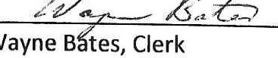Meeting adjourned by consensus at 9:08 a.m.

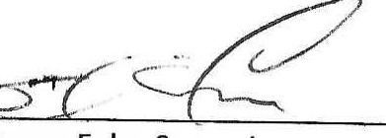
Steven Fuhr, Supervisor

