CHARTER TOWNSHIP OF GENESEE ORDINANCE NO. 632
AN ORDINANCE TO AMEND ORDINANCE NO. 603, THE GENESEE CHARTER TOWNSHIP ZONING ORDINANCE, BY THE ADDITION OF CREMATORIUM TO CERTAIN ZONING DISTRJCTS THEREBY AMENDING ARTICLES X AND XI
The Charter Township of Genese'e, Genesee County, Michigan Ordains:

SECTION I
The Genesee Township Zoning Ordinance is hereby amended by the addition of crematorium as a use permitted by right as follows:

ARTICLE X - C-2 HIGHWAY COMMERCIAL, SECTION 1001
Section 1001 Uses Permitted by Right
9A: Crematorium

ARTICLE XI-I-1 LIGHT INDUSTRIAL, SECTION 1101
Section 1101 Uses Permitted by Right
2. The following uses shall be permitted:
h. Crematorium

SECTION II

REPEAL
All ordinances and portions thereof insofar as the same may be in conflict herewith are hereby repealed.

SECTION III
EFFECTIVE DATE

This Ordinance shall become effective upon the 30th day following publication.

SECTION IV

INSPECTION OF ORDINANCE
A copy ofthis Ordinance may be inspected at the Township Clerk's Office at the Genesee Township Hall, 7244 N. Genesee Road, Genesee, Michigan during regular business hours.

We hereby certify that the foregoing Ordinance was adopted on the Second Reading by the Township Board of the Charter Township of Genesee at its meeting on October 10, 2023.

First Reading: September 12, 2023

Second Reading: Published on:
October 10, 2023

September 20, 2023
October 18, 2023

1st Reading 2nd Reading

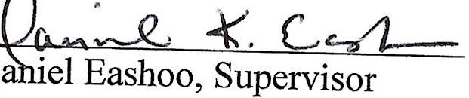

Wa :Bates, Clerk

