CHARTER TOWNSIDP OF GENESEE ORDINANCE NO. 633
AN ORDINANCE TO AMEND ORDINANCE NO. 603, THE GENESEE CHARTER TOWNSHIP ZONING ORDINANCE BY THE REZONING CERTAIN LAND
R-2 (SINGLE FAMILY /TWO FAMILY RESIDENTIAL to 1-1 LIGHT INDUSTRIAL

The Charter Township of Genesee, Genesee County, Michigan Ordains:
SECTION I

REZONING OF PREMISES

Genesee Township Ordinance No. 603 is hereby amended to read as follows:
Pursuant to Article XVII Section 1706 entitled "Changes and Amendments" the zoning ordinance and zoning map is hereby amended pursuant to the recommendation of the Genesee Township Planning Commission, the following described premises in the Township of Genesee, Genesee County, Michigan are hereby rezoned from R-2 Single-Family/ Two-Family Residential to 1-1 Light industrial:

Parcel No.: 11-19-552-078

LOTS 72 & 73 LYNCROFT (82) FR 1100172101

MORE COMMONLY KNOWN AS: Vacant Land -Holtslander, Flint, MI 48505
SECTION II

REPEAL

All ordinances and portions thereof insofar as the same may be in conflict herewith are hereby repealed.
SECTION III
EFFECTIVE DATE

This Ordinance shall become effective immediately upon publication following its final adoption.

SECTION IV

SHORT TITLE

This Ordinance shall be known as Genesee Township Zoning Ordinance Amendment No.

2023-633.
We hereby certify that the foregoing Ordinance was adopted on the Second Reading by the Township Board of the Charter Township of Genesee at its meeting on December 12 > z.a...2.3., 2023.

First Reading:
Second Reading: Published on:
November 21,2023

December 12, 2023

December 6, 2023

Second Publication December 20, 2023

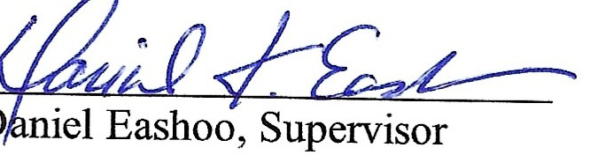

;V.. ,,-4. 1):5
Wayne1f.iates, Clerk

2

